**Fruit Festival (Ben Tre)**

Cai Mon - Lach market, Ben Tre is a rich land that is alluvial all year round thanks to Ham Luong and Co Chien rivers. Therefore, this land has many green gardens, making the garden economy of the people also develop. For tourists, hearing the name Cai Mon - Cho Lach, Ben Tre is referring to fruit specialties such as durian, rambutan, mangosteen, grapefruit, longan, jackfruit...

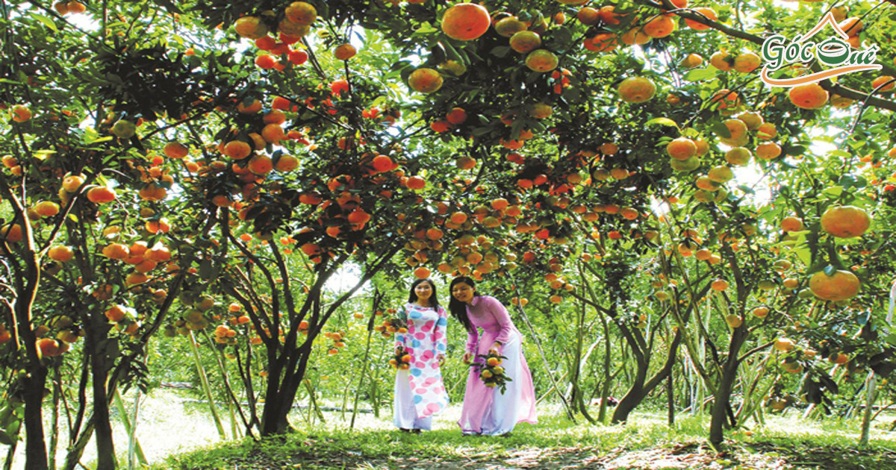

Delicious and safe fruit festival Cho Lach - Ben Tre

Until the next appointment, in June this year, Ben Tre province again organized a 'Delicious and safe fruit festival' for locals and tourists everywhere to visit and enjoy. The West is a rich land with lush orchards, including fruits that are considered specialties.

Some famous fruit brands in the Southwest region such as Hoang Gia pomelo (Vinh Long), Hoang Kim melon (Hau Giang), Hoang Hau dragon fruit (Long An), Cai Mon durian (Ben Tre), Vinh Kim breast milk, Sa Dec breast milk, Hoa Loc sand mango (Dong Thap), Vinh Kim honey orange (Tien Giang), longan canoe, Vinh Kim seedless guava...

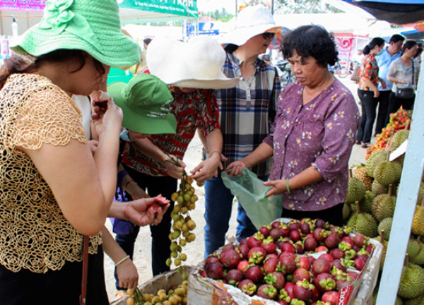

The 15th delicious and safe fruit festival in Cho Lach district, Ben Tre will take place from June 17, 2021 to the end of June 21, 2021, on the occasion of the Dragon Boat Festival on the 5th day of the 5th lunar month. This festival has a very large scale, which is expected by many locals and tourists across the country.

The theme of this year's festival is 'Ben Tre Fruits integration and development' with contents such as delicious and safe fruit contest in the Mekong Delta, fruit trickery, food market, and fruit market. This is considered an opportunity for western garden farmers to challenge each other in the technology of planting and caring for fruit trees, ornamental plants, seedlings... And this festival is also the event. opportunities to learn, exchange experiences with each other, is also a place to honor the superior products of farmers.

Visitors to the Western Tour to Ben Tre at this time will have the opportunity to participate in the festival, see the Western fruits, enjoy and buy as gifts.

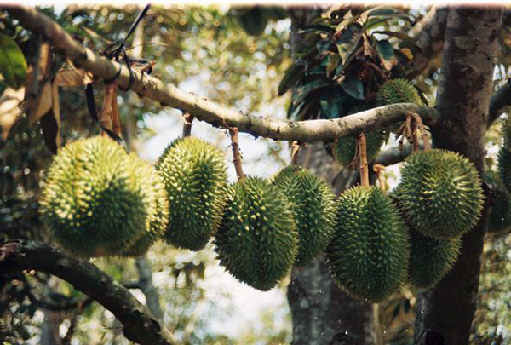

Traveling to Ben Tre to participate in the fruit festival

Cai Mon - Lach market, Ben Tre is a rich land that is alluvial all year round thanks to Ham Luong and Co Chien rivers. Therefore, this land has many green gardens, making the garden economy of the people also develop.

For tourists, hearing the name Cai Mon - Cho Lach, Ben Tre is referring to fruit specialties such as durian, rambutan, mangosteen, pomelo, longan, jackfruit... In addition, this is also the land of the profession. growing flowers, planting large ornamental plants 'No. 1' in the Southwest region.

All these things help Cho Lach district, Ben Tre for many years to be chosen as the place to hold a delicious and safe fruit festival. And because of this, Cai Mon and Cho Lach have become prominent tourist destinations of Ben Tre tourism in particular, and Western tourism in general.

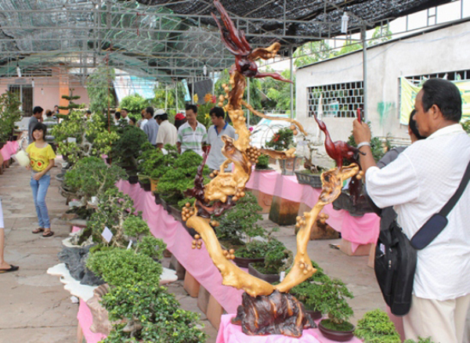

The 15th delicious and safe fruit festival in Cho Lach district, Ben Tre is a good opportunity for tourists from all over the country to come back to admire and enjoy fragrant flowers and sweet fruits. The festival promises to bring many new things to visitors, especially the competition of big, long, heavy and strange fruits and the contest of green - clean - beautiful fruit gardens.

Visitors will be able to see firsthand the strange fruits and vegetables, enjoy the famous fruit specialties of the West. According to the general information of Viet Fun Travel, the festival will open at 19:30 on June 17, 2021 at the main stage, the People's Committee of the old district of Cho Lach.

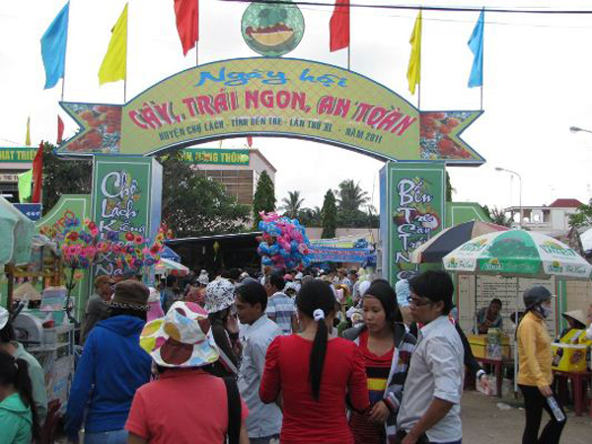

The delicious and safe fruit festival in Cho Lach district, Ben Tre 2021 is a program organized by the People's Committee of Ben Tre province, allowing Cho Lach district to coordinate with departments and agencies to organize for local people and tourists. have the opportunity to exchange, learn experience in cultivation and techniques to care for plants, varieties and fruits. This job is to maintain and develop the profession of seedlings, ornamental flowers and growing delicious fruits, the economic strength of the Western garden. This is also a way to go to the West, specifically traveling to Ben Tre to promote its image to domestic and foreign tourists.